OTHER INFORMATION – TRACK & FIELD 2023
COMMUNICATION
- Coaches will communicate with parents & athletes through the Remind App
- To receive text messages on daily track & field schedules, updates, & announcements do the following. Please only have one parent OR athlete subscribe.
  - Text this number: 81010
    - Text this message: @93bfhc
TRANSPORTATION HOME FROM MEETS
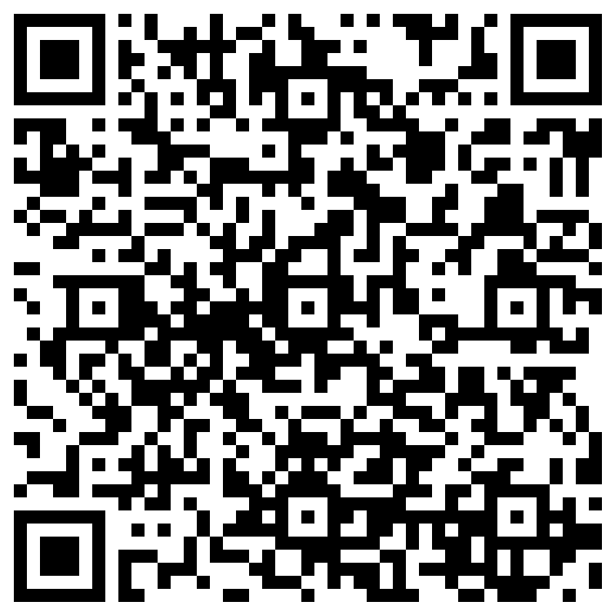
*QR CODE FOR BUS RELEASE FORM:
- If athlete will NOT be riding the bus back to South Davis after the meet concludes, a parent/guardian is required to fill out the form located on the Track & Field page of the South Davis website (see steps below) – Form needs to be filled out before the conclusion of the meet
- Form needs to be filled out for each meet that athlete is NOT riding the bus back to South Davis
- If form is NOT filled out before the meet ends, athlete will be required to ride the bus back to South Davis
*Steps to form: South Davis webpage (https://southdavisjr.davis.k12.ut.us) - Activities - Athletics - Track and Field

PHYSICALS
- Physicals need to be completed & uploaded to Register My Athlete by the first day of practice – physicals are valid for 365 days, but CAN NOT expire during the season
- If athlete has already had a physical within the past 365 days, and physical will not expire during the season, they do NOT need to get another physical – upload a copy of your physical to Register My Athlete
- If you do not have a copy of your physical, call your physician and see if you can go pick one up – let them know it is for high school athletic participation
- If you can’t get a copy of your physical or see your regular physician in time, some clinics do walk-in sports physicals, no appointment needed – call nearby clinics & ask if they do walk-in sports physicals OR go to one of the clinics listed below:
  - Medallus Medical: 1868 N. 1200 W., Layton, UT 84041
    - Phone: (801) 614-2772 / Monday through Sunday 9 AM – 7 PM
  - Ogden Clinic: 991 W. Shepard Lane, Suite 200, Farmington, UT 84025
    - Phone: (801) 397-6080 / Monday through Friday 8 AM – 5 PM

